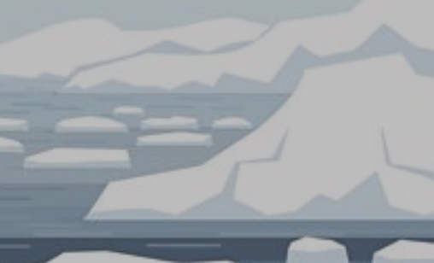

Antartica

Can you use the BBC Antartica website to answer the questions below?

- How low can the temperature get in Antartica?…………………………………..

- Is Antartica at the North Pole or South Pole?………………………………………

- What is the name of a piece of land that extends out from a larger piece of land and is mostly surrounded by water? ……………………………………………………………………………………………………………

- What animal lives on Antartica?…………………………………………………………….

- What is the name of the buildings that researchers live in while working on Antartica?………………………………………………………………………………………..

Can you write you own 3-4 questions below about Antartica that a classmate can use the website to find the answers to?

