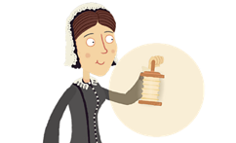

Florence Nightingale

Can you use the BBC Florence Nightingale website to answer the questions below?

- Which war did Florence Nightingale nurse soldiers in?

- Florence Nightingale was also known as the …………………………………………………………..

- Why did she write books?

- When she returned from the war she didn’t want people to know who she was so she called herself Miss ………………………………………

- What was the name of her pet owl?

Can you write you own 3-4 questions below about Florence Nightingale that a classmate can use the website to find the answers to?

