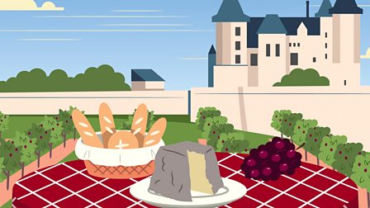

France

Can you use the BBC France website to answer the questions below?

- What is the smallest country in the world?……………………………………………

- What city is the Eiffel tower and Mona Lisa painting in?………………………

- What sea is at the south of France?………………………………………………………

- What activity do people do in the Alps?……………………………………………..

- What is the name of the cathedral in Paris?…………………………………………

Can you write you own 3-4 questions below about France that a classmate can use the website to find the answers to?

