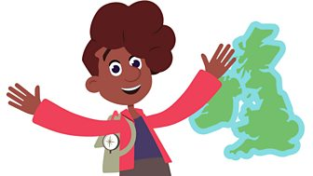

United Kingdom

Can you use the BBC United Kingdom website to answer the questions below?

- What is the capital city of Wales?…………………………………………………………

- What is a Loch?…………………………………………………………………………………….

- What hemisphere is the United Kingdom in?…………………………………………

- What country is the Giant’s Causeway in?……………………………………………..

- What country is Edinburgh the capital city of?…………………………………………

Can you write you own 3-4 questions below about the United Kingdom that a classmate can use the website to find the answers to?

