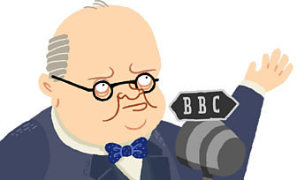

Winston Churchill

Can you use the BBC Winston Churchill website to answer the questions below?

- What year did WW2 start?

- Which countries helped to defeat Germany?

- What year did Winston Churchill lose the election?

- What did Winston Churchill enjoy doing in his spare time?

- What was the name for his onesie and when did he wear it?

Can you write you own 3-4 questions below about Winston Churchill that a classmate can use the website to find the answers to?

