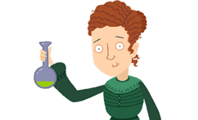

Marie Curie

Can you use the BBC Marie Curie website to answer the questions below?

- Marie Curie was a very famous………………………………………………………………..

- She discovered …………………………………………………………..

- What prize was she awarded?

- Why did Marie Curie’s parents have to send her to university in secret?

- What did Marie Curie do in World War One?

Can you write you own 3-4 questions below about Marie Curie that a classmate can use the website to find the answers to?

