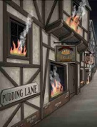

Great Fire of London

Can you use the BBC Great Fire of London website to answer the questions below?

- What was the name of the baker that (probably) started the fire?

- Give 2 reasons why the fire spread so quickly?

- How many houses and churches did the fire destroy?

- Why did people blow up buildings?

- Who wrote a diary about the Great Fire of London?

Can you write you own 3-4 questions below about the Great Fire of London that a classmate can use the website to find the answers to?

