Queen Elizabeth ll
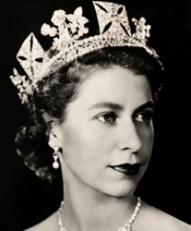

Can you use the BBC Queen Elizabeth ll website to answer the questions below?

- When did Princess Elizabeth become Queen of the United Kingdom?

- How old was Queen Elizabeth ll when she came to the throne?

- Where did Queen Elizabeth ll die and what was the date?

- What is the Monarch head of? Give 3 answers.

- What was Queen Elizabeth’s husband called?

- When was Queen Elizabeth ll’s first child born?

Can you write you own 3-4 questions below about Queen Elizabeth ll that a classmate can use the website to find the answers to?

