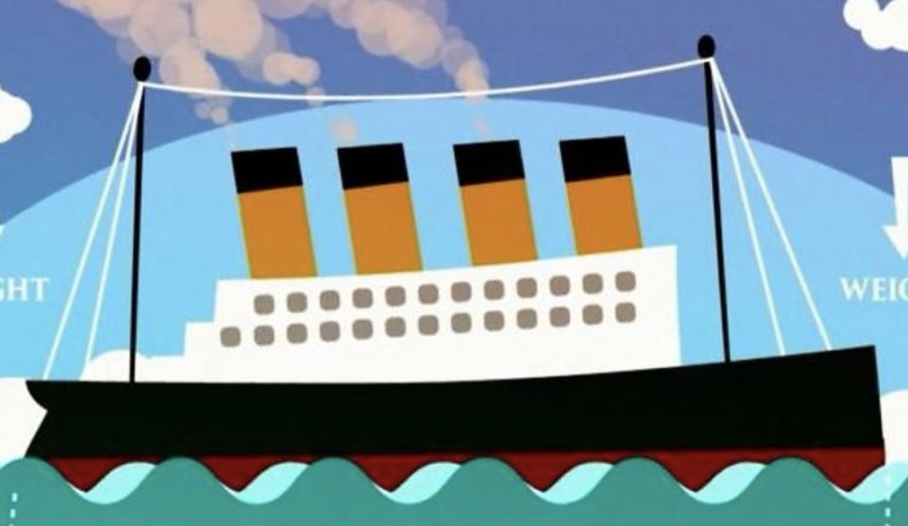

Titanic

Can you use the BBC Titanic website to answer the questions below?

- How much money did the Titanic cost to build?…………………………………..

- What was the fourth funnel on the ship used for?……………………………….

- Who discovered displacement (how ships float)? ……………………………………………………………………………………………………………

- How many people were on board the Titanic?……………………………………

- How much did a first class ticket cost?…………………………………………………

Can you write you own 3-4 questions below about the Titanic that a classmate can use the website to find the answers to?

