Has achieved
PYTHON Programming basics

This is to certify that
Joe Bloggs
On
19/02/2019
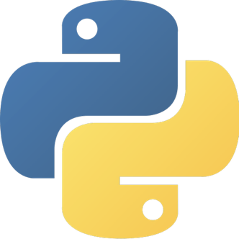
AwardED by
ADAM FOSTER
fOUNDER OF www.iLEARN2.co.uk

